**SHIMONI DEMONSTRATION SCHOOL-KIRA**

**MID TERM TWO EXAMINATIONS, 2024**

**P.4 INTEGRATED SCIENCE**

**NAME: ……………………………………………………………………………**

***SECTION A***

1. Which type of soil is the best for growing crops?

________________________________________________________________________

2. Name the food value we get from eating fish.

________________________________________________________________________

3. Give any one example of crop pests.

________________________________________________________________________

4. Identify any one element of weather.

________________________________________________________________________

5. Write any one disease spread by houseflies.

________________________________________________________________________

6. Name the organ of flowering plants drawn below.

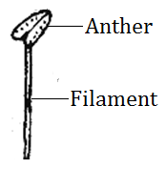

_____________________________________________________

7. Give one reason why people eat food.

________________________________________________________________________

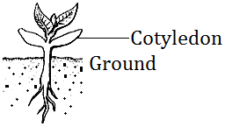8. Which type of germination is shown below?

_________________________________________________

9. Identify the sense organ for smelling.

________________________________________________________________________

10. Which instrument is used to show the direction of wind?

________________________________________________________________________

11. Name the crop pest drawn below.

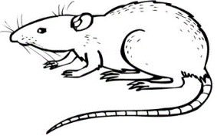

___________________________________________________________

12. How do flowering plants reproduce?

________________________________________________________________________

13. Give any one method of preserving food.

________________________________________________________________________

14. State any one way of caring for crops in the garden.

________________________________________________________________________

15. What are weeds?

________________________________________________________________________

________________________________________________________________________

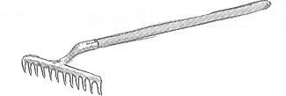16. Name the garden tool drawn below.

________________________________________________________________________

17. Which type of clouds brings rain?

________________________________________________________________________

18. Why do people brush teeth after eating food?

________________________________________________________________________

19. Identify any one food stuff that is a source of carbohydrates.

________________________________________________________________________

20. Name the vector which spread cholera germs.

________________________________________________________________________

21. Which body organ stores information?

________________________________________________________________________

22. In which season do farmers harvest their crops?

________________________________________________________________________

23. Name the food made by plants.

________________________________________________________________________

24. Why do passion fruit plants climb other plants?

________________________________________________________________________

25. State any one method of preparing food.

________________________________________________________________________

26. Give one way through which food gets contaminated.

_______________________________________________________________________

27. Draw any simple leaf in the space given below.

28. Why do farmers mulch their gardens?

________________________________________________________________________

29. Which gas do animals breathe in?

________________________________________________________________________

30. Name one condition necessary for germination to take place.

________________________________________________________________________

31. State any one way of keeping the class clean.

________________________________________________________________________

32. Which mineral salt makes teeth and bones hard?

________________________________________________________________________

33. What do fish use for breathing?

________________________________________________________________________

34. Mention any one disease of people.

________________________________________________________________________

35. Besides crocodiles, which other animals live in water.

________________________________________________________________________

36. Name the sweet juice found in flowers.

________________________________________________________________________

37. Name the type of root system drawn below.

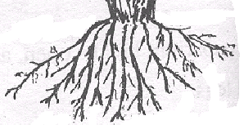

________________________________________________________________________

38. Give any one example of deficiency diseases.

________________________________________________________________________

39. How are germs dangerous to people?

________________________________________________________________________

40. Name any one crop which is first planted in the nursery bed.

________________________________________________________________________

***SECTION B***

41. (a) Name any one weather element.

________________________________________________________________________

(b) Which weather instrument is shown below?

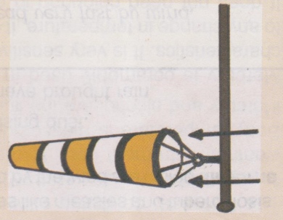

_________________________________________________

(c) Name any two uses of rainfall to man.

(i) ____________________________________________________________

(ii) ___________________________________________________________

42. (a) Give any one example of a domestic animal reared for transport.

________________________________________________________________________

(b) What are wild animals?

________________________________________________________________________

________________________________________________________________________

(c) Give anyone example of a wild animal which destroys maize in the garden.

________________________________________________________________________

(d) Give one importance of animals to man.

________________________________________________________________________

43.**Match the following correctly**.

Pistil attracts pollinators

Ovary produces pollen grains

Petals develops into a fruit

Anther female part of a flower

(i)Pistil

(ii) Ovary

(iii) Petals

(iv) Anther

44. (a) Name any one method of harvesting crops.

________________________________________________________________________

(b) Give any one garden tool used by farmers.

________________________________________________________________________

(c) Give any two ways of taking care of garden tools.

(i) _______________________________________________________________

(ii) ______________________________________________________________

45. ***Below is a pistil***.

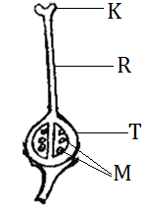

(a) Name the part labeled R.

________________________________________________________________________

(b) Which part results into seeds after fertilization?

________________________________________________________________________

(c) Give any two uses of flowers to man.

(i) ________________________________________________________________

(ii) ________________________________________________________________

46. (a) Why are some plants first planted in a nursery bed?

________________________________________________________________________

________________________________________________________________________

(b) Give any one crop that is first planted in the nursery bed.

________________________________________________________________________

(c) Give the garden tool used in transplanting seedlings.

________________________________________________________________________

(d) Mention any one way of caring for seeds in a nursery bed.

________________________________________________________________________

47. ***Study the diagram below and answer the questions that follow***.

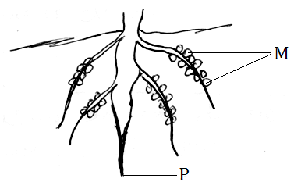

(a) Which type of root system is drawn above?

________________________________________________________________________

(b) Give any one example of a crop with such roots.

________________________________________________________________________

(c) Name the parts marked

(i) P __________________________________________________________

(ii) M _________________________________________________________

48. (a) What is personal hygiene?

________________________________________________________________________

________________________________________________________________________

(b) Name any two things used for keeping our bodies clean.

(i) __________________________________________________________________

(ii) __________________________________________________________________

(c) Name any one disease that results from poor personal hygiene.

________________________________________________________________________

49. (a) What is food?

________________________________________________________________________

________________________________________________________________________

(b) Give any two classes of food.

(i) ________________________________________________________

(ii) ________________________________________________________

(c) Give any one reason why people eat food.

________________________________________________________________________

50. (a) Name the body organ that pumps blood to all parts of the body.

________________________________________________________________________

(b) Name the body organs responsible for:

(i) Seeing __________________________________________________

(ii) Hearing _______________________________________________

(iii) Feeling ________________________________________________

51. (a) Name any one natural water source.

________________________________________________________________________

(b) Give any two importance of water to a farmer.

(i) _________________________________________________________

(ii) ________________________________________________________

(c) Name the type of clouds that give us relief rainfall.

________________________________________________________________________

52. (a) Give any one example of a crop that needs staking.

________________________________________________________________________

(b) Give any two examples of common weeds.

(i) _________________________________________________________

(ii) ________________________________________________________

(c) Name any one method of controlling crop weeds.

________________________________________________________________________

53. (a) Which instrument is used to measure the human body temperature?

________________________________________________________________________

(b) Name the liquid used in the clinical thermometer.

______________________________________________________________________

(c) Name the instrument used to keep delicate weather instruments.

________________________________________________________________________

(d) Give one use of a rain gauge.

_______________________________________________________________________

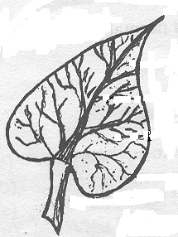54. ***Below is a simple leaf***.

(a) Name the breathing organs found on a leaf.

________________________________________________________________________

(b)Name the type of leaf venation shown above.

________________________________________________________________________

(c) Give two functions of leaves to people.

(i) _____________________________________________________________________

(ii) __________________________________________________________________

55. (a) Draw the following garden tools.

|  |  |  |
| --- | --- | --- |
| panga | forked hoe | watering can |
|  |  |  |

(b) Give one way of caring for garden tools.

________________________________________________________________________

***\*\*\*\*\*GOD BLESS YOU\*\*\*\*\****